WEEK 4 VIRTUAL DATA SCIENCE REPORT
Supervised Learning Model Implementation
Breast Cancer Classification using Logistic Regression
Python • Pandas • NumPy • Scikit-learn • Matplotlib

1. Introduction
Supervised learning uses labelled examples to learn a relationship between input features and a target variable. This project develops a binary classification model using the Breast Cancer Wisconsin dataset available through Scikit-learn. The model predicts whether a recorded tumour is classified as malignant or benign from numerical measurements computed from digitized images of breast masses.
The project follows a complete predictive modelling workflow: dataset inspection, target definition, data-quality checks, train-test splitting, preprocessing, model training, cross-validation, evaluation, visualization, feature analysis, error analysis, and discussion of limitations and possible improvements.

2. Problem Definition and Objective
The supervised learning problem is a binary classification task. Given the 30 numerical diagnostic features for a sample, the model predicts one of two classes: malignant or benign. The objective is to build a reliable baseline classifier and evaluate not only its overall accuracy but also its ability to correctly identify each class.
- Define the target as the dataset's binary class label.
- Prepare numerical features without introducing information leakage.
- Scale the predictors because Logistic Regression is sensitive to feature magnitude during optimization.
- Train a Logistic Regression classifier.
- Validate performance using stratified five-fold cross-validation.
- Evaluate the held-out test set using accuracy, precision, recall, F1-score and ROC-AUC.
- Inspect the confusion matrix and model coefficients to understand errors and feature influence.

3. Dataset Description
The Breast Cancer Wisconsin dataset contains 569 observations and 30 numerical predictor variables. The target contains two classes. In the Scikit-learn representation, target 0 corresponds to malignant and target 1 corresponds to benign.
Property | Value
Observations | 569
Predictor features | 30
Target classes | 2
Feature type | Numerical
Missing feature values | 0
Duplicate feature rows | 0
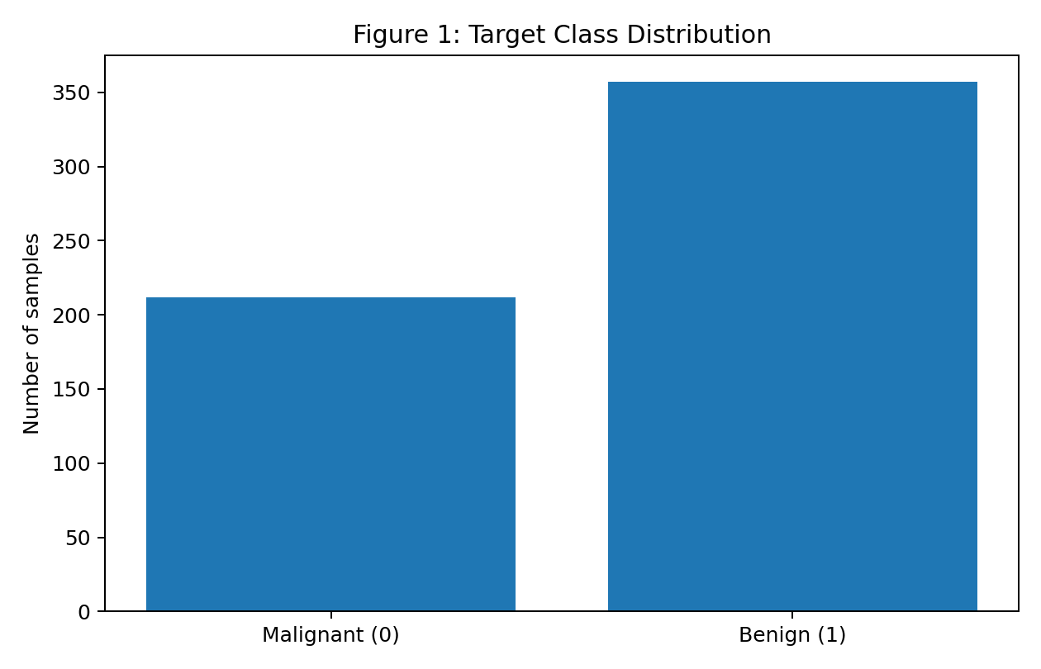
The target distribution contains 212 malignant (37.3%) and 357 benign (62.7%) observations. The classes are not exactly equal, which is why stratification was used during the train-test split and cross-validation. Preserving the class proportions prevents a small test set from becoming unusually dominated by one class.

4. Feature Understanding
The predictors describe characteristics such as radius, texture, perimeter, area, smoothness, compactness, concavity, concave points, symmetry, and fractal dimension. For several measurements, the dataset provides mean, standard error, and worst-case versions, creating multiple related predictors.
- Mean radius represents an average size-related measurement.
- Mean texture represents an average texture-related measurement.
- Mean perimeter and mean area describe additional size-related characteristics.
- Mean concavity and mean concave points capture shape-related characteristics.
- Worst-radius, worst-perimeter and worst-area provide extreme or upper-level measurements for a sample.
Because several variables measure related properties, the model is not expected to treat all 30 features as independent pieces of information. This makes coefficient inspection useful for understanding which measurements contribute strongly to the fitted linear decision boundary.

5. Data Quality and Preprocessing
The feature matrix contains 0 missing values and 0 exact duplicate rows. Because no missing feature values were found, no imputation was required. The absence of missing values avoids introducing estimated values that could affect model coefficients.
The target column was kept separate from the predictors. It was never passed into the feature matrix. This is essential because using the target as an input would cause target leakage and produce an artificially optimistic model.

5.1 Train-Test Split
X_train, X_test, y_train, y_test = train_test_split(
X, y, test_size=0.20, random_state=42, stratify=y
)
Twenty percent of the observations were reserved as a final hold-out test set. Stratification preserves approximately the same malignant/benign proportion in both training and test sets. The test set was not used to fit preprocessing parameters or model coefficients.

5.2 Feature Scaling
from sklearn.pipeline import Pipeline
from sklearn.preprocessing import StandardScaler
from sklearn.linear_model import LogisticRegression
pipe = Pipeline([
("scaler", StandardScaler()),
("model", LogisticRegression(max_iter=5000, random_state=42))
])
StandardScaler was placed inside a Pipeline so that scaling is fitted only on the training data in each cross-validation split. This prevents information from the validation fold from influencing preprocessing. Scaling is particularly appropriate here because the predictors use different numerical ranges; without scaling, variables with larger magnitudes can have a disproportionate effect on optimization and coefficient comparisons.
Preprocessing therefore affects both model training and interpretation. After scaling, the coefficient magnitude can be compared more meaningfully because the predictors are placed on a common standardized scale. However, the coefficients should still be interpreted as model associations rather than proof of biological causation.

6. Model Selection: Logistic Regression
Logistic Regression was selected as the primary model because the task has two target classes and the model provides a direct, interpretable classification baseline. It produces class probabilities, which makes ROC-AUC analysis possible, and its coefficients allow the contribution of standardized predictors to be examined.
The model is also suitable as a baseline because it is relatively simple compared with more complex ensemble methods. A strong baseline provides a reference point against which future models such as Random Forest or Support Vector Machine can be compared.
model = LogisticRegression(max_iter=5000, random_state=42)
pipe.fit(X_train, y_train)

7. Model Validation
A single train-test split provides a final independent test estimate, but relying on one split can make the reported score sensitive to which observations happen to fall into the test set. Therefore, five-fold stratified cross-validation was also performed on the available dataset.
Fold | Accuracy | F1-score | ROC-AUC
1.000 | 0.974 | 0.979 | 0.995
2.000 | 0.947 | 0.959 | 0.998
3.000 | 0.965 | 0.973 | 0.985
4.000 | 0.991 | 0.993 | 1.000
5.000 | 0.991 | 0.993 | 0.999
Across the five folds, mean accuracy was 0.974 with a standard deviation of 0.019. Mean F1-score was 0.979 and mean ROC-AUC was 0.995. The relatively small fold-to-fold variation indicates that the baseline's performance is reasonably consistent across different validation partitions.
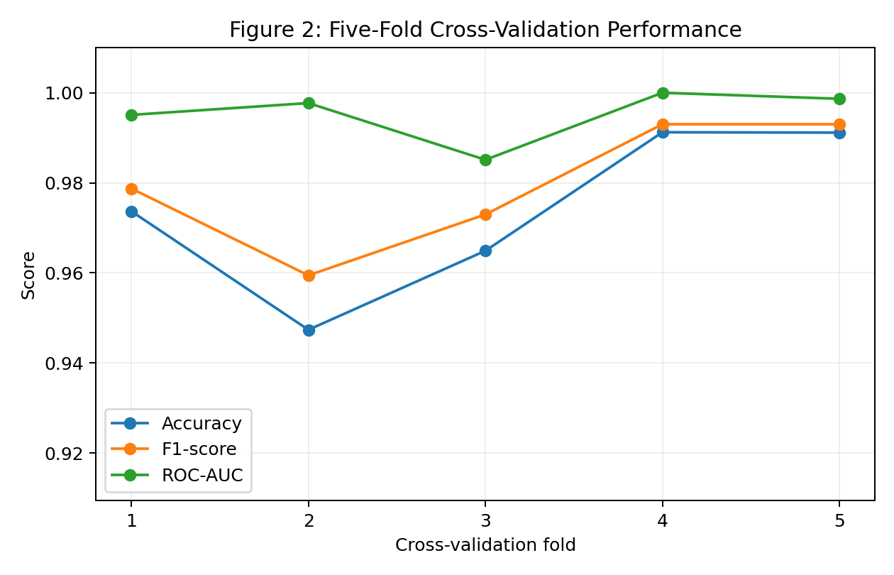

8. Test Set Evaluation
Metric | Score
Accuracy | 0.982
Precision | 0.986
Recall | 0.986
F1-score | 0.986
ROC-AUC | 0.995
On the held-out test set, the model achieved an accuracy of 0.982, meaning that 112 of 114 test observations were classified correctly. Precision was 0.986, recall was 0.986, F1-score was 0.986, and ROC-AUC was 0.995.
These metrics provide different information. Accuracy summarizes overall correctness, precision measures the reliability of positive predictions, recall measures how many actual positive cases are detected, F1-score balances precision and recall, and ROC-AUC summarizes ranking performance across classification thresholds. Looking at several metrics is more informative than reporting accuracy alone.

9. Confusion Matrix and Error Analysis
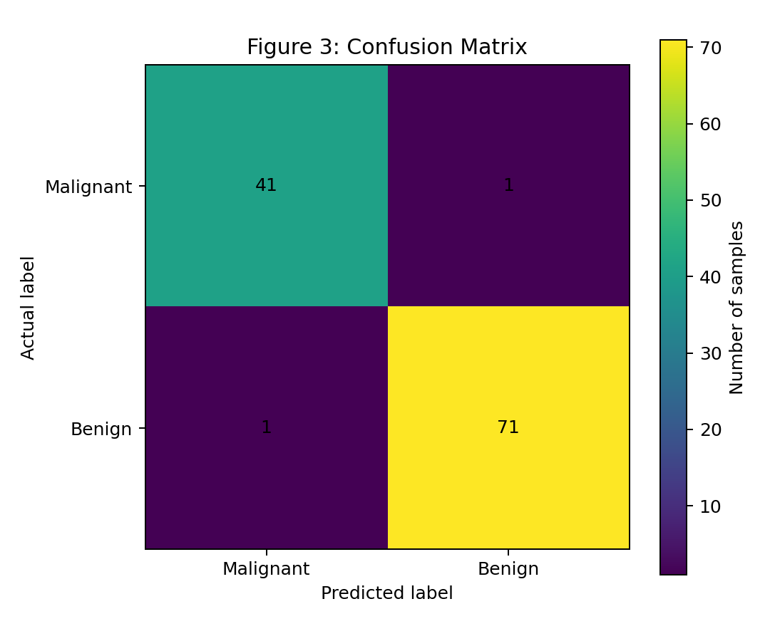
The confusion matrix contains 41 true malignant predictions, 1 malignant observations predicted as benign, 1 benign observations predicted as malignant, and 71 true benign predictions. These counts show exactly where the classifier succeeded and where it made mistakes.
For a medical-style classification problem, the type of error matters more than accuracy alone. A malignant case incorrectly predicted as benign is a false negative and is particularly important because the model fails to flag a positive condition. This demonstrates why recall and the confusion matrix should be reported alongside accuracy. The model is a machine-learning demonstration and is not a clinical diagnostic system.

9.1 Misclassified Observations
The test set contained 2 misclassified observations. These errors show that the two classes are not perfectly separable using a simple linear decision boundary based on the available predictors.
Sample | Actual | Predicted | Probability_Benign
541 | Benign | Malignant | 0.366
73 | Malignant | Benign | 0.909
The probability values for errors can also indicate borderline cases. Predictions close to the decision boundary are less decisive than predictions with probabilities close to 0 or 1. This supports the idea that model errors can arise when observations have feature combinations that resemble the other class.

10. ROC Curve Analysis
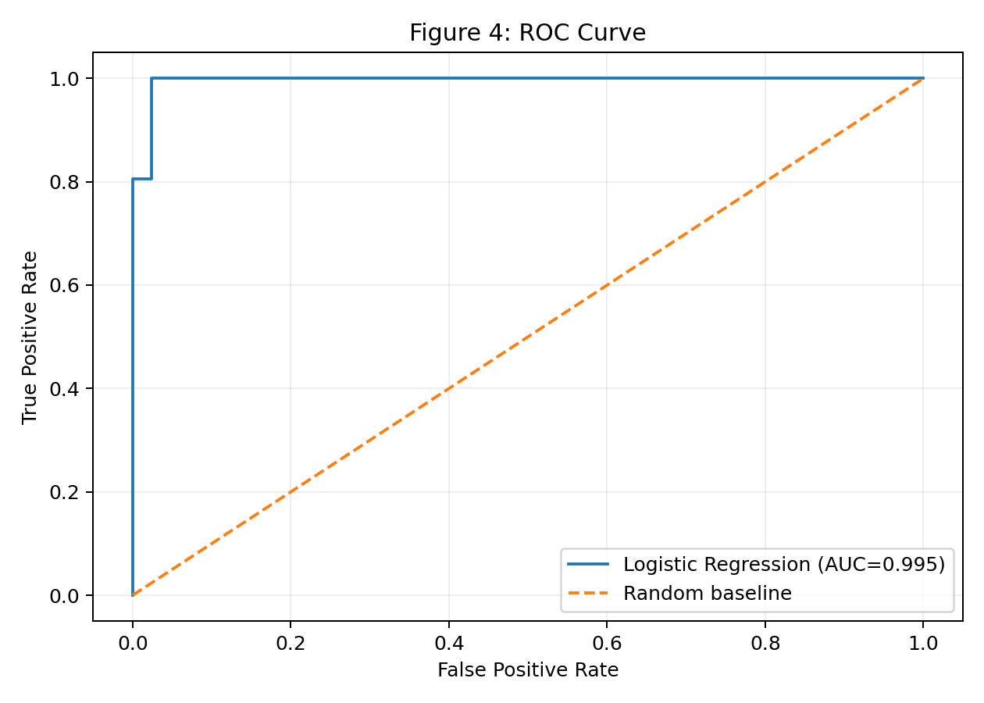
The ROC curve compares the true-positive rate with the false-positive rate across different classification thresholds. The test ROC-AUC is 0.995. A value closer to 1 indicates stronger ability to rank the two classes across thresholds, while a value around 0.5 would indicate performance close to random ranking.
The curve also highlights an important practical point: the default classification threshold is not necessarily optimal for every application. If missing a malignant case were considered especially costly, a future system could investigate threshold selection using validation data rather than changing the threshold based on the test set.

11. Feature Engineering and Model Coefficients
The project primarily uses the existing numerical measurements rather than creating arbitrary derived variables. The main feature-engineering step is standardized representation through StandardScaler. This keeps the original diagnostic information while putting predictors on a comparable scale.
Feature | Coefficient | Absolute coefficient
worst texture | -1.255 | 1.255
radius error | -1.083 | 1.083
worst concave points | -0.954 | 0.954
worst area | -0.948 | 0.948
worst radius | -0.948 | 0.948
worst symmetry | -0.939 | 0.939
area error | -0.929 | 0.929
worst concavity | -0.823 | 0.823
worst perimeter | -0.763 | 0.763
worst smoothness | -0.747 | 0.747
mean concave points | -0.704 | 0.704
mean compactness | 0.648 | 0.648
compactness error | 0.647 | 0.647
mean concavity | -0.602 | 0.602
mean texture | -0.553 | 0.553
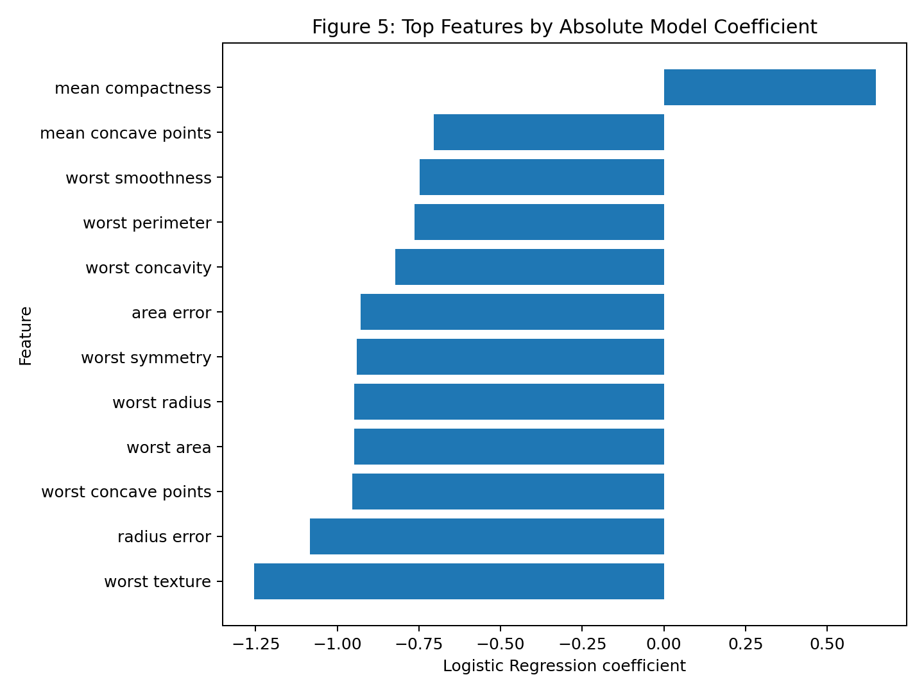
The coefficient table ranks predictors by absolute coefficient magnitude. Because the features were standardized, larger absolute coefficients indicate that a one-standard-deviation change in that predictor has a relatively stronger effect on the model's linear log-odds calculation, holding the other model inputs constant. The sign indicates the direction of the model relationship with the encoded benign class. These coefficients describe the model's statistical behaviour and should not be interpreted as independent causal effects.

12. Strengths of the Model
- Provides an interpretable baseline for a binary classification problem.
- Uses a Pipeline to prevent preprocessing leakage during validation.
- Uses stratified train-test splitting and stratified five-fold cross-validation.
- Reports multiple evaluation metrics rather than relying only on accuracy.
- Produces probabilities, enabling ROC-AUC and threshold analysis.
- Provides coefficients that can be inspected to understand the fitted linear decision boundary.

13. Limitations
- Logistic Regression assumes a linear relationship between standardized predictors and the log-odds of the target.
- Several predictors are related measurements, which can introduce redundancy and coefficient instability.
- The dataset is relatively small compared with many real-world machine-learning datasets.
- The final test result depends partly on the chosen train-test split, although cross-validation provides additional evidence of stability.
- The model should not be treated as a medical diagnostic tool; clinical decisions require validated systems, appropriate data, and expert oversight.
- Coefficient magnitude does not establish causation and can be affected by correlation among predictors.

14. Possible Model Improvements
- Compare Logistic Regression with Random Forest, Support Vector Machine, and other classification algorithms.
- Use regularization tuning with GridSearchCV or RandomizedSearchCV to optimize model hyperparameters.
- Investigate feature selection or dimensionality reduction to reduce redundancy among correlated predictors.
- Perform threshold analysis using validation data when recall or another metric is more important than default accuracy.
- Use repeated cross-validation to obtain a more stable estimate of model variability.
- Compare calibrated probability outputs if probability quality is important for downstream decisions.

15. Key Findings and Original Analysis
- The model achieved 98.2% accuracy on the unseen test set, correctly classifying 112 of 114 test observations.
- The test ROC-AUC of 0.995 indicates strong ranking performance across classification thresholds.
- Five-fold cross-validation produced a mean accuracy of 0.974, providing a second estimate beyond the single hold-out test score.
- The test confusion matrix contains 1 false negatives and 1 false positives, showing exactly which types of mistakes were made.
- The model made 2 errors on the test set, demonstrating that even a high-performing baseline does not separate every observation correctly.
- Standardization was integrated inside the modelling pipeline, reducing the risk of leakage and making coefficient magnitudes more comparable.
- The combination of test metrics, cross-validation, confusion matrix, ROC curve, and coefficient analysis provides a more complete evaluation than accuracy alone.

16. Conclusion
This project implemented a complete supervised learning workflow for binary classification using the Breast Cancer Wisconsin dataset. The data was inspected for quality, separated into predictors and target, and split into training and test sets using stratification. Standardization was applied within a Pipeline so that scaling was learned only from training data during both model fitting and cross-validation.
Logistic Regression was selected as an interpretable baseline and evaluated using five-fold stratified cross-validation and a held-out test set. The final test accuracy was 0.982, with F1-score 0.986 and ROC-AUC 0.995. The confusion matrix and error analysis provided additional insight into the types of predictions that were incorrect. Overall, the project demonstrates how careful preprocessing, leakage-aware validation, multiple evaluation metrics, and model interpretation work together to create a stronger supervised learning analysis.

17. Reproducibility
All numerical results and figures in this report were generated from the Python workflow included in the appendix. The use of random_state=42 makes the train-test split and model setup reproducible under the same software environment. The Scikit-learn dataset is loaded directly through load_breast_cancer(), so a separate dataset download is not required.

18. Complete Python Code Appendix
# Week 4 - Supervised Learning Model Implementation
# Breast Cancer Classification using Logistic Regression
from sklearn.datasets import load_breast_cancer
from sklearn.model_selection import train_test_split, StratifiedKFold, cross_val_score
from sklearn.preprocessing import StandardScaler
from sklearn.pipeline import Pipeline
from sklearn.linear_model import LogisticRegression
from sklearn.metrics import (
accuracy_score, precision_score, recall_score,
f1_score, roc_auc_score, confusion_matrix,
roc_curve
)
# Load dataset
bc = load_breast_cancer(as_frame=True)
df = bc.frame.copy()
# Separate predictors and target
X = df.drop(columns=["target"])
y = df["target"]
# Train-test split
X_train, X_test, y_train, y_test = train_test_split(
X, y,
test_size=0.20,
random_state=42,
stratify=y
)
# Scaling + Logistic Regression pipeline
pipe = Pipeline([
("scaler", StandardScaler()),
("model", LogisticRegression(
max_iter=5000,
random_state=42
))
])
# Train model
pipe.fit(X_train, y_train)
# Predictions
y_pred = pipe.predict(X_test)
y_prob = pipe.predict_proba(X_test)[:, 1]
# Evaluation
print("Accuracy:", accuracy_score(y_test, y_pred))
print("Precision:", precision_score(y_test, y_pred))
print("Recall:", recall_score(y_test, y_pred))
print("F1-score:", f1_score(y_test, y_pred))
print("ROC-AUC:", roc_auc_score(y_test, y_prob))
# Confusion matrix
print("Confusion Matrix:")
print(confusion_matrix(y_test, y_pred))
# Five-fold stratified cross-validation
cv = StratifiedKFold(
n_splits=5,
shuffle=True,
random_state=42
)
cv_accuracy = cross_val_score(
pipe, X, y, cv=cv, scoring="accuracy"
)
print("CV Accuracy:", cv_accuracy)
print("Mean CV Accuracy:", cv_accuracy.mean())
# ROC curve
fpr, tpr, thresholds = roc_curve(y_test, y_prob)
# Feature coefficients
coefficients = pipe.named_steps["model"].coef_[0]
for feature, coefficient in sorted(
zip(X.columns, coefficients),
key=lambda x: abs(x[1]),
reverse=True
):
print(feature, coefficient)

19. References
Scikit-learn documentation and the built-in Breast Cancer Wisconsin diagnostic dataset were used for this implementation. The project uses load_breast_cancer, train_test_split, StandardScaler, Pipeline, LogisticRegression, StratifiedKFold, cross_val_score, and classification evaluation metrics from Scikit-learn.

